Use the software PyCharm to import opencv to read images, Import mat, use the function EuclideanDistTrackerWrite the code for tracking, using.

Importing opencv to read images in a live recorded video.

With a stable camera having a stable background to record against, the number of vehicles in the video will only change over time, so the aim now is to extract moving objects.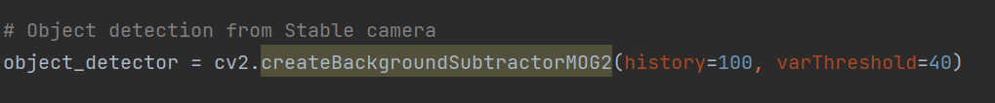

So come to object detection using a stabilised camera.

Extraction of effective pixels:

At first I only wanted to detect vehicles in the right-hand range, but the other vehicles were too big an obstacle and needed to be narrowed down, so I used findContours.

This is followed by the deletion of redundant elements, setting that if the pixels are greater than 100 they will only be captured and anything less than 100 pixels will be discarded and not used.

Set a certain range:

The original height and width were 780x1200, however I wanted the middle position, so set the height range 340-720 and the width range 500-800. cv2.imshow("roi",roi), refers to the detection of vehicles entering the area.路旁的轨道上行驶



Optimisation of interface accuracy:

By removing the grey areas, all below 254 only a clearer white range is required, so that the capture is also more precise.